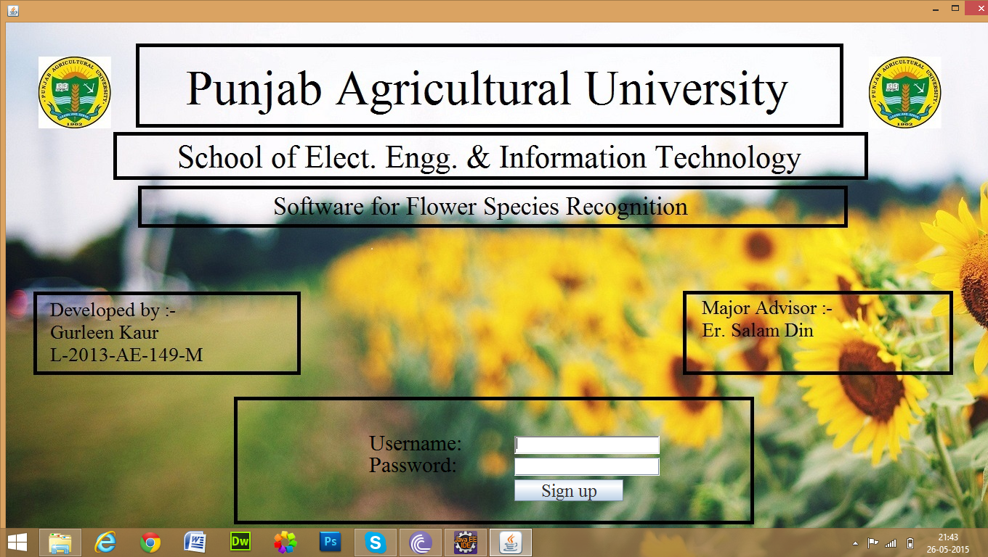

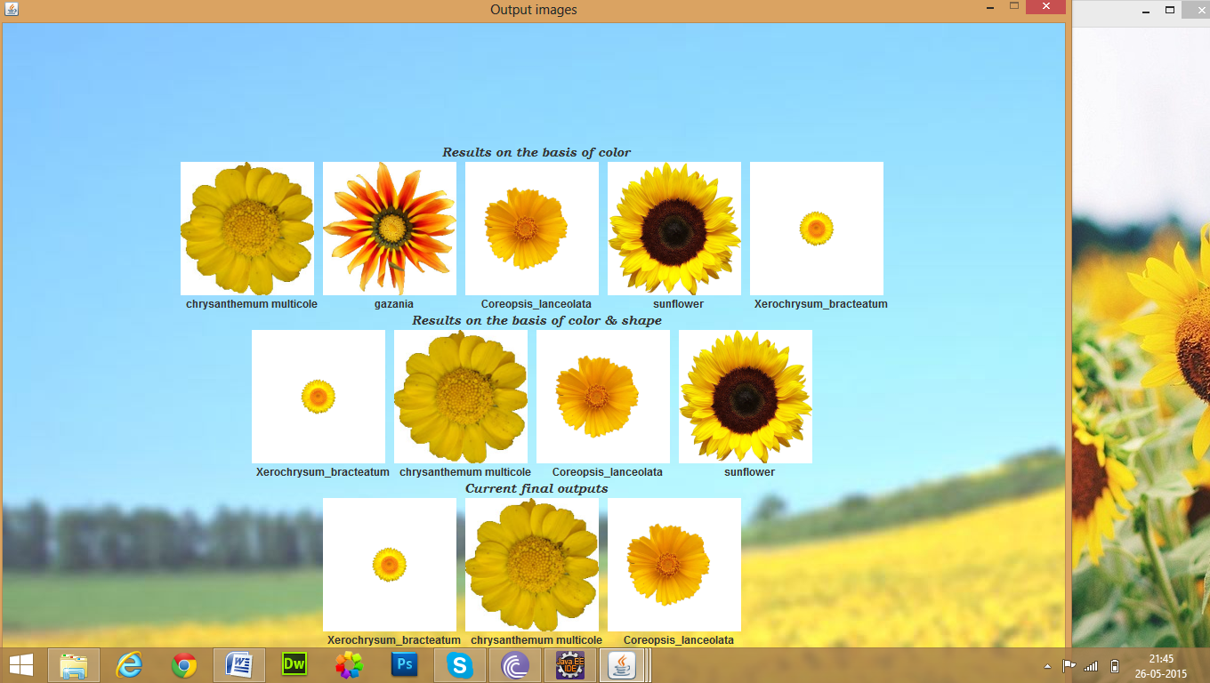

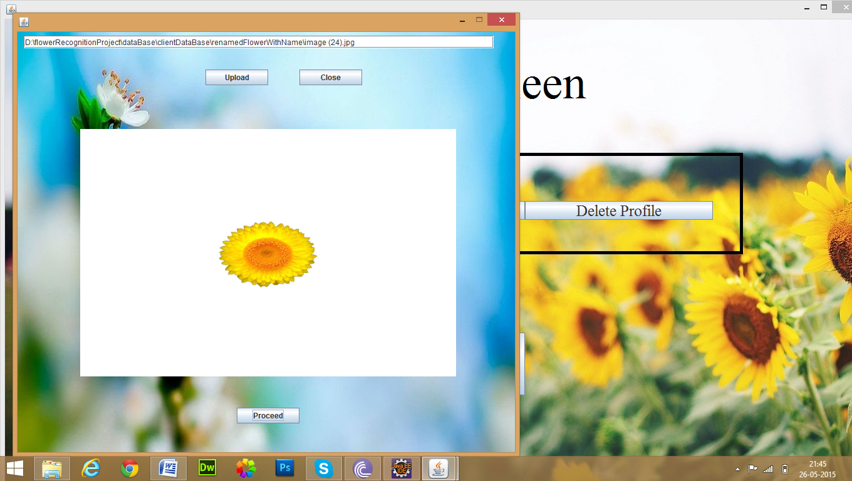

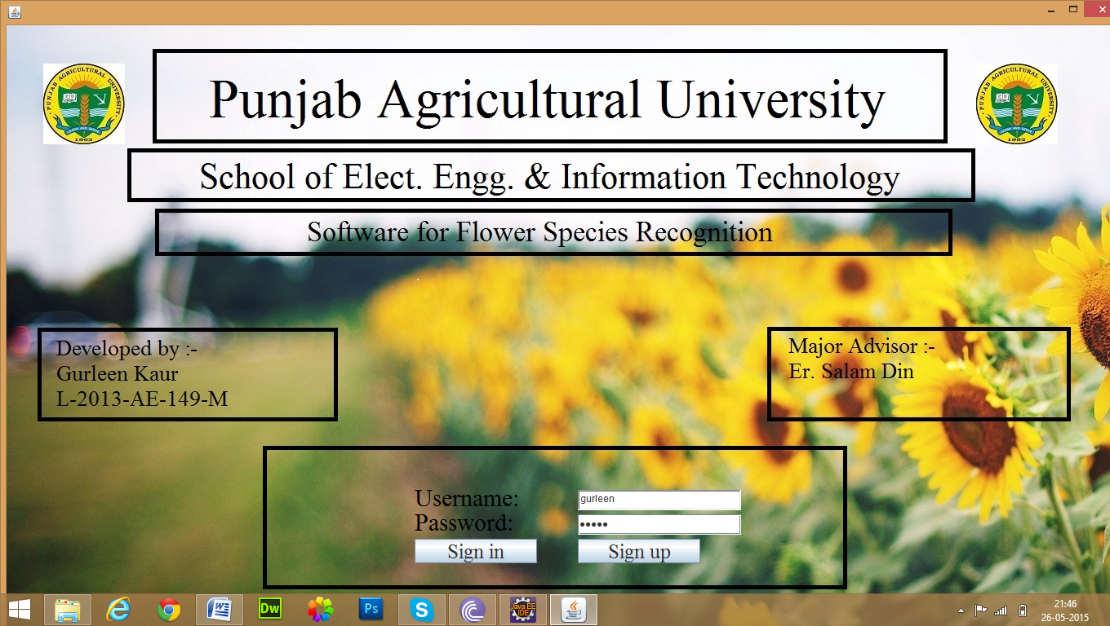

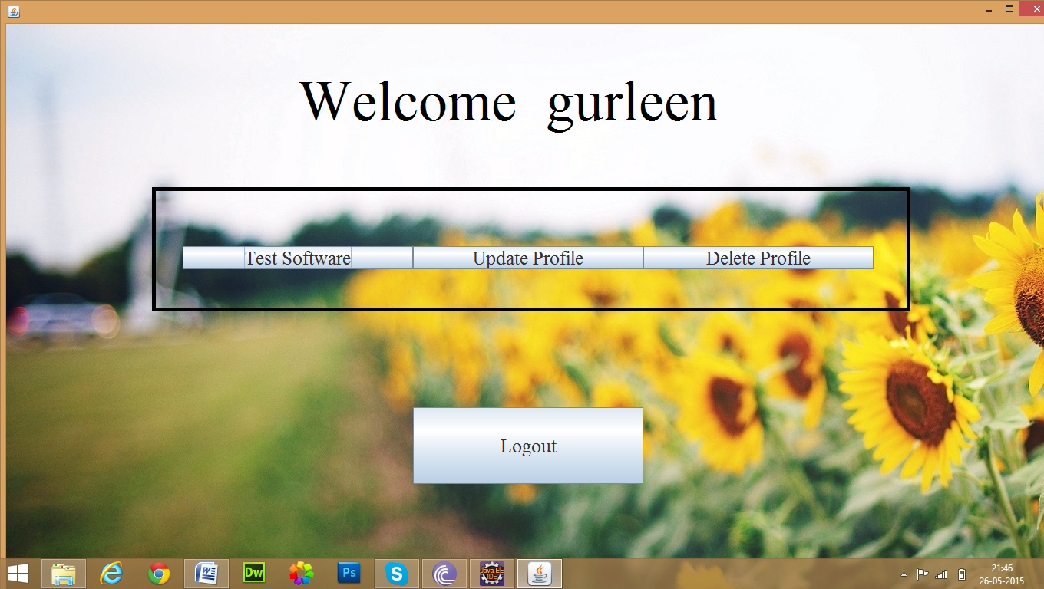

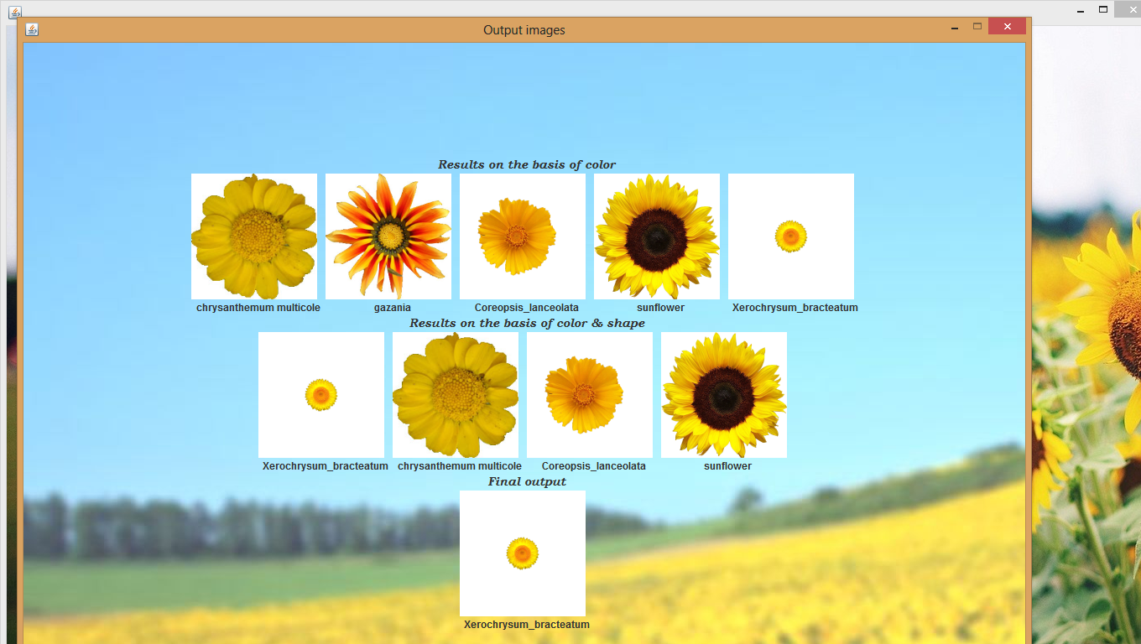

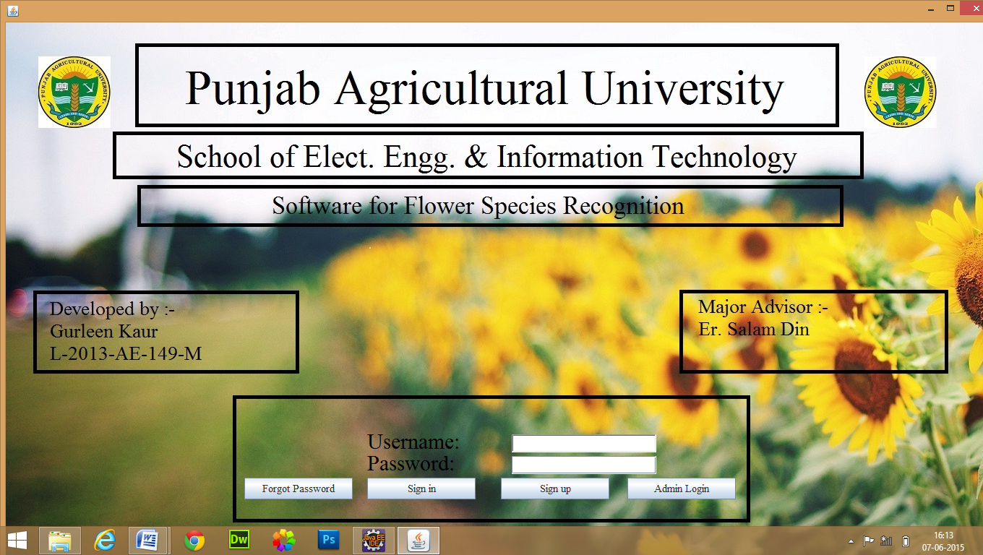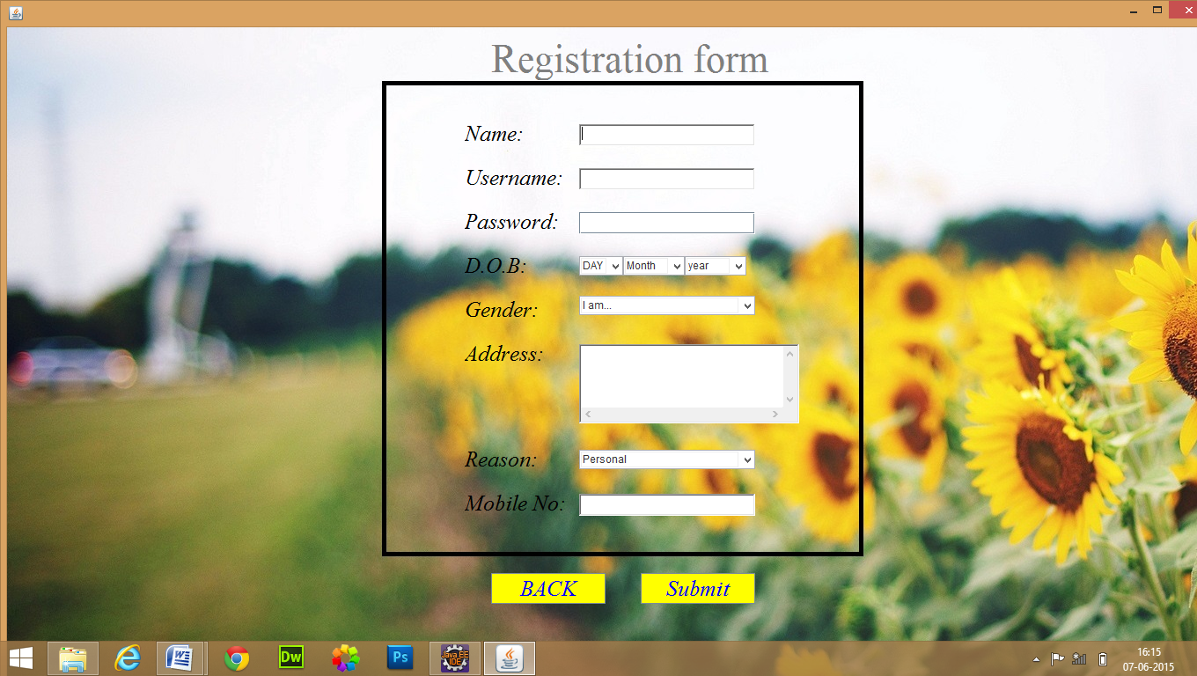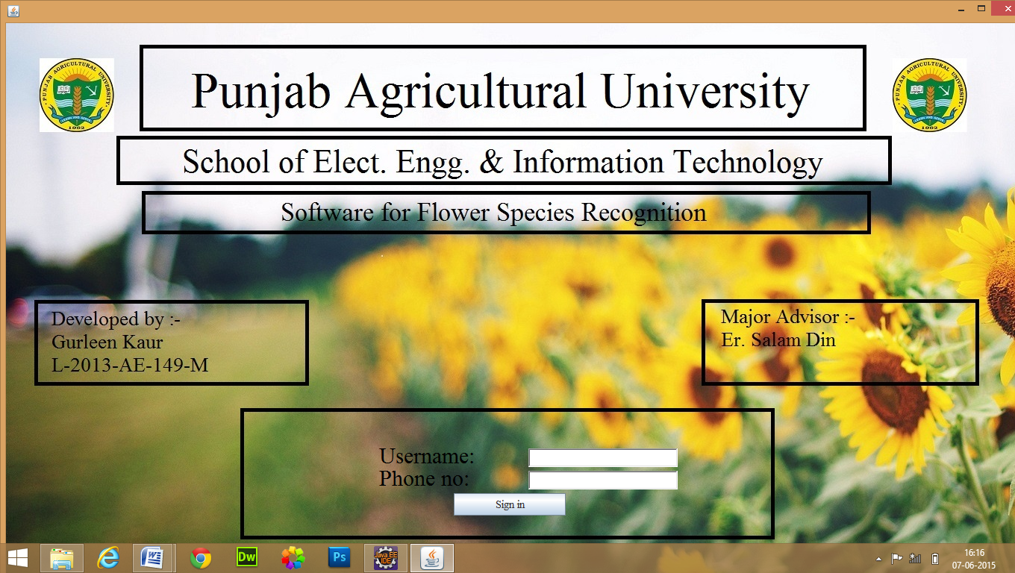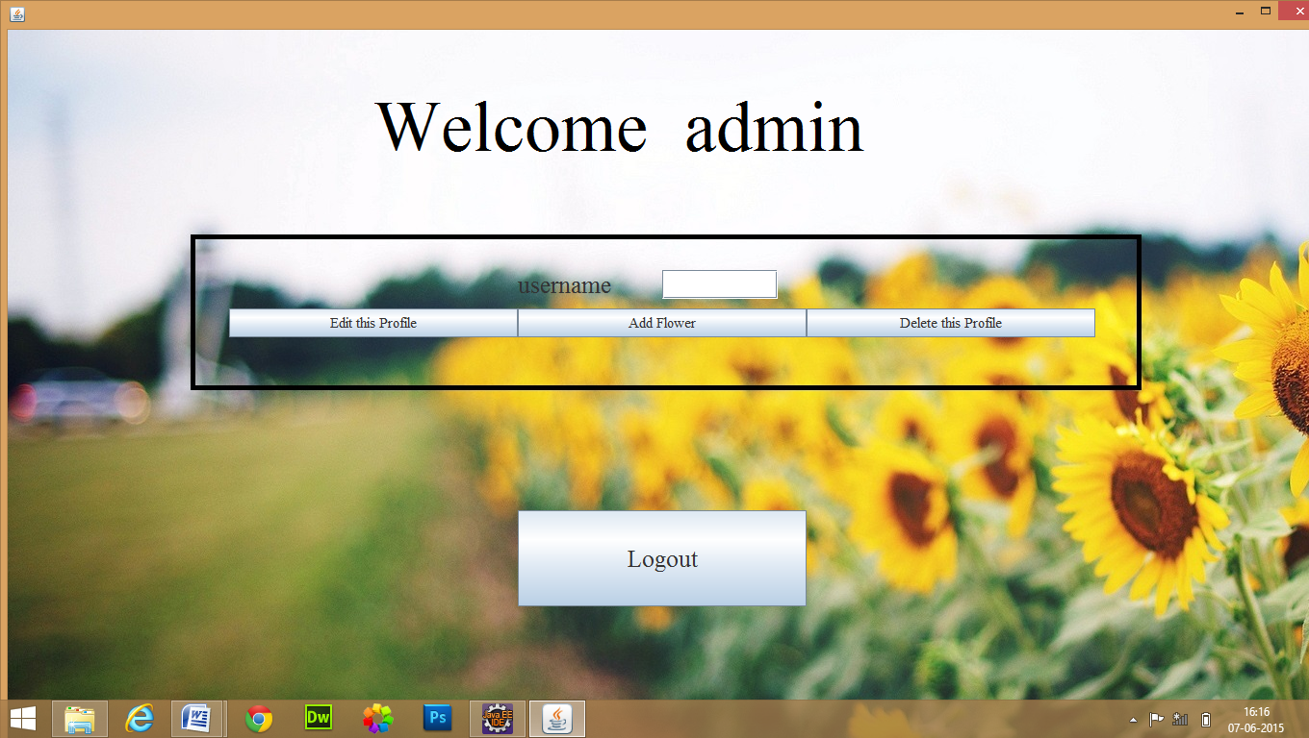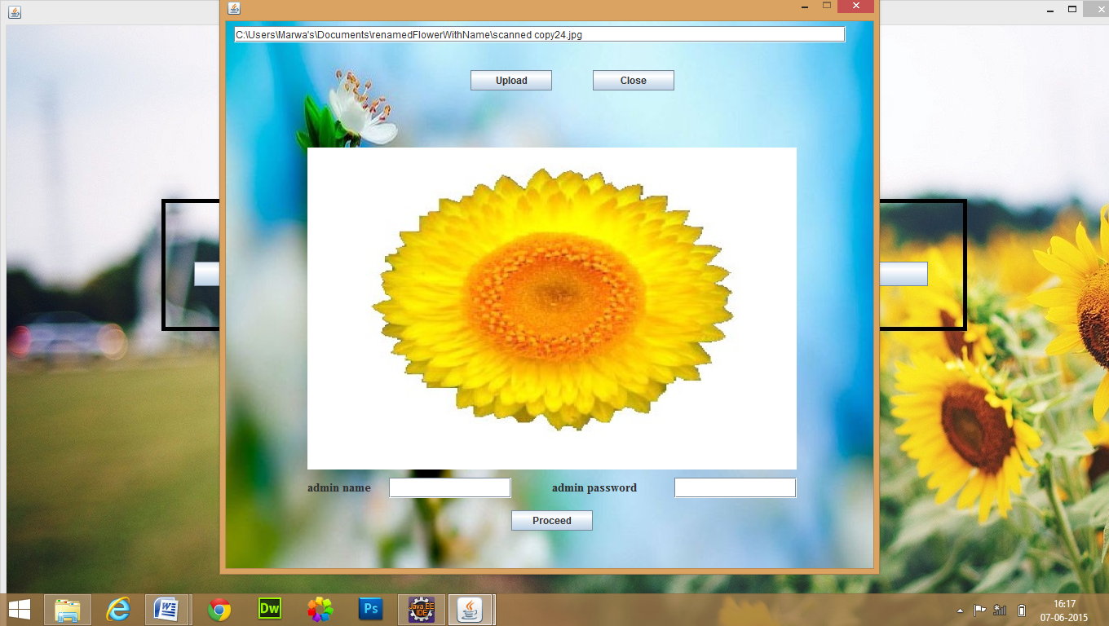

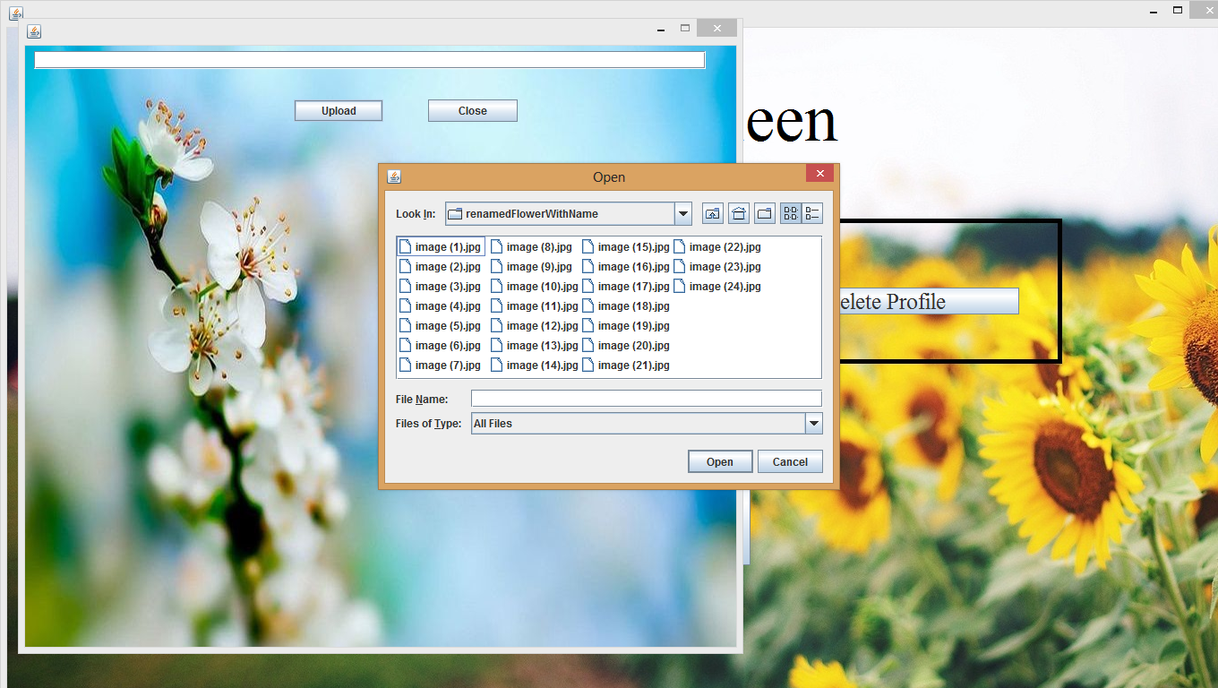

|  |  |  |  |
| --- | --- | --- | --- |
| Sr. no. | Scientific name | Number of images | Sample image |
|  |  | 3 |  |
|  |  | 3 |  |
|  |  | 2 |  |
|  |  | 4 |  |
|  |  | 2 |  |
|  |  | 2 |  |
|  |  | 3 |  |
|  |  | 2 |  |
|  |  | 4 |  |
|  |  | 2 |  |
|  |  | 3 |  |
|  |  | 2 |  |
|  |  | 4 |  |
|  |  | 3 |  |
|  |  | 2 |  |
|  |  | 2 |  |
|  |  | 3 |  |
|  |  | 3 |  |
|  |  | 2 |  |
|  |  | 3 |  |
|  |  | 4 |  |
|  |  | 2 |  |
|  |  | 2 |  |
|  |  | 3 |  |
| 49 colour nd sh | 8 colour (img 6,13,20) | 65 total (all img 21 not detected) | 54 colour shape nd st |